Application Architecture:
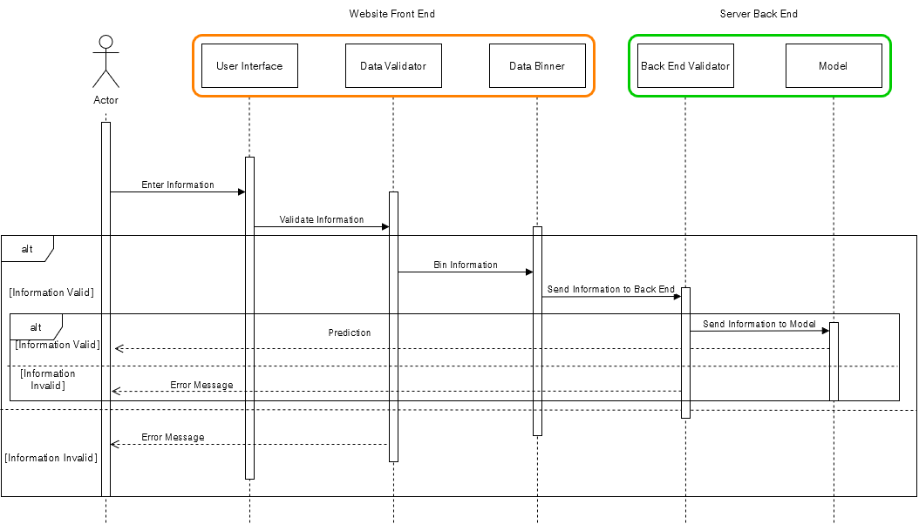

Our application is separated into 2 parts. The first part is the front end and the second part is the back end.
The front end is responsible for collecting data from the user and validating it. If the data is valid, it is binned and sent to the back end to create a prediction. If it is not, the user is given an error message explaining which input caused the error message.
The front end is going to be in the form of a website developed using the NEXT.js framework. It will contain fields asking the user for the information. To begin, the user will choose using radio buttons for most fields since the fields are binary. For the non-binary fields, they will be made to insert a number with a certain range that depends on the nature of the question like general health rating, number of days where you felt physically unwell, BMI, etc. For the education level and income inputs, they will select from a drop-down menu the range they fall under.
Once the data has been entered, the numerical inputs will be validated for type and range then if all is well the data is binned into the data form used in training during prior phases. The data is then sent as a JSON object to the model’s backend using an API call.
The backend will be written in Java and will implement the machine learning model discussed in the previous part. It will have a listener responsible for receiving any incoming API requests and will validate the data just in case it got corrupted or tampered with during transfer. If the data is faulty, a return API call is sent to indicate an issue. The data is then used by the model to predict whether or not the user has diabetes based on the data sent. The prediction is sent as another JSON object to the user through an API call and the user receives their prediction.

